Deerwalk Institute Of Technology
Database Administration

Lab: 6

Submitted By: Submitted To:
Name: Sagar Giri Narayan Chalise
Roll No. 205
Date:
Managing Roles
- Create a user.
- Create a role.
- Assign Role to the user.
- Grant Roles

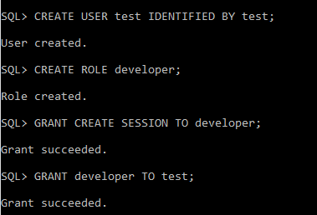

Granting Privileges
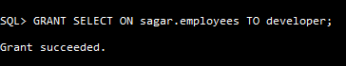

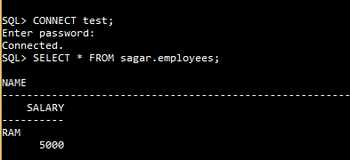
Accessing from another user

